**Ant Colony Optimization**

**(Homework # 1)**

**­­­**

**By**

**Selim Serbatas M. Shahzeb Malik**

**114200049 115200007**

**Supervised by**

**Uzay Cetin**

**Faculty of Engineering and Natural Sciences**

**Computer Engineering**

**Istanbul Bilgi University**

**2019 – 2020**

1. **How Ant Colony Optimization Works?**

It is an Algorithm for finding optimal paths that is based on ant’s life as they go out from their home every day. In the search of food, they walk randomly but when they find food they throw pheromone on their way to the food and way back, When other ants come across the pheromone on way, they are likely to follow the path with a certain probability. If they do, they then populate the path with their own pheromone as they bring the food back. As more ants find the path, it gets stronger until there are a couple streams of ants traveling to various food sources near the colony.

Because the ants drop pheromones every time they bring food, shorter paths are more likely to be stronger, hence optimizing the "solution." In the meantime, some ants are still randomly scouting for closer food sources.

A similar approach can be used find near-optimal solution to the traveling salesman problem.

Once the food source is depleted, the route is no longer populated with pheromones and slowly decays.

Because the ant-colony works on a very dynamic system, the ant colony algorithm works very well in graphs with changing topologies. Examples of such systems include computer networks, and artificial intelligence simulations of workers.

1. **Environment**

Environment function is created to see a distance matrix type plot to understand from what environment ant walks by and how much pheromone it leaves on it way and how other ants follow him and which helps us in finding the shorted path for visiting cities by Automation mode ( without telling ants what to do). It’s the basic beginning of Ant optimization colony to start with.

1. **Ant Class**

In Ant Class we used Mov, deposit, run and cost functions which helped us in taking ants from starting point to the end point without giving them command to go where.

Next step was to find the true path for that we first used the pheromone update formula which guided us to check the shortest path ants took and how they reach their colony.

After that we will check the result of 50 points and went from one to another then the Shortest path it took from that and in the end to know the starting and ending point by the metrices.

Then we used the algorithm to see the visual plot graph of our result using Matplotlib.

In last we check the pheromone in the matrix of 50x50 from which we understood that the points which high pehromone are the shortest way for reaching from one place to other.

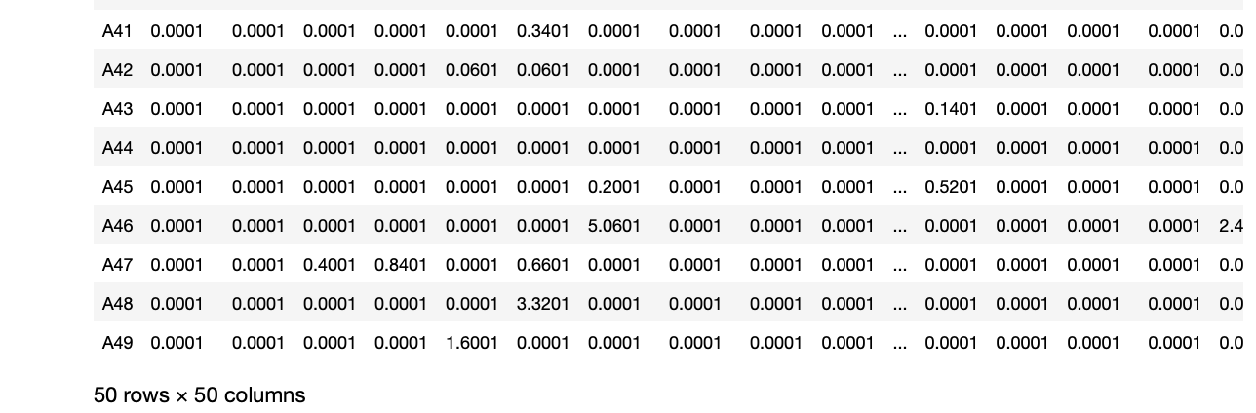

1. **Ant Colony Class**

In Ant colony class we wrote many different libraries instead of importing their libraries. The purpose of this class is to find shortest path using iteration, np.array for distances, decay and important functions like run. Which helped us in finding one shortest way for act to pass with highest pheromone level in the area.

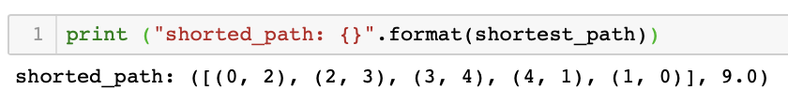.

After that we plotting a graph using Travelling salesperson plot. It starts from the point (2,0) then it goes to (2,3) till it reached the last point and complete the circle.

